Sumanth Donthula

**CS 480 Spring 2023 Written Assignment #04**

Due: **Wednesday, April 19, 2023, 11:59 PM CST**

Points: **45**

**Instructions:**

1. Use this document template to report your answers. Name the complete document as follows:

LastName_FirstName_CS480_Written04.doc

1. Submit the final document to Blackboard Assignments section before the due date. No late submissions will be accepted.

**Objectives:**

1. (10 points) Demonstrate your understanding of Bayes Networks.
2. (35 points) Demonstrate your understanding of Decision Networks.

**Problem 1 [10 pts]:**

We are given the following Bayesian network over X2, X3, …, X9. Note that there is no X1.

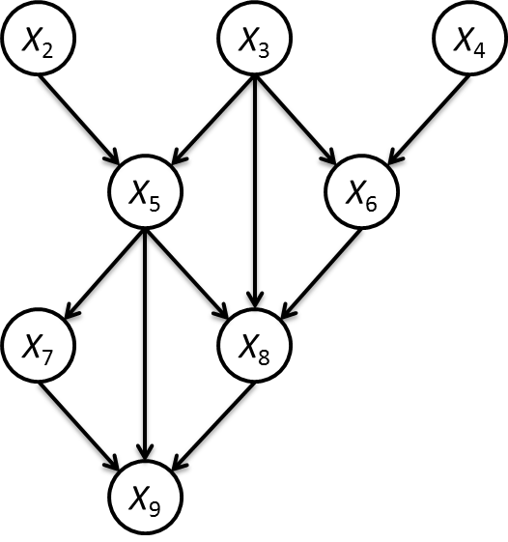

What is the Bayesian network factorization of the joint probability **P**(X2, X3, …, X9)?

|  |
| --- |
| **Your solution:** |
| Parents of all nodes: So, each of the nodes probability is influential by their parents  X9:{X8,X7,X5}  X8:{X3,X5,X6}  X7:{X5}  X6:{X3,X4}  X5:{X2,X3}  X4: No Parents  X3: No Parents  X2: No Parents  Based on the given Bayesian network and from chain rule, we can write the factorization of the joint probability as follows:  P(X2……..X9) = P(X9| X8,X7,X5) * P (X8| X3,X5,X6) * P (X7| X5) * P(X6| X3,X4) * P(X5| X3,X2) * P(X2,X3,X4)  Since X2,X3,X4 are independent : P(X2,X3,X4) = P(X2) * P(X3) * P(X4)  P(X2……..X9) = P(X9| X8,X7,X5) * P (X8| X3,X5,X6) * P (X7| X5) * P(X6| X3,X4) * P(X5| X3,X2) * P(X2) * P(X3) * P(X4) |

**Problem 2 [35 pts]:**

We are given the following decision network:

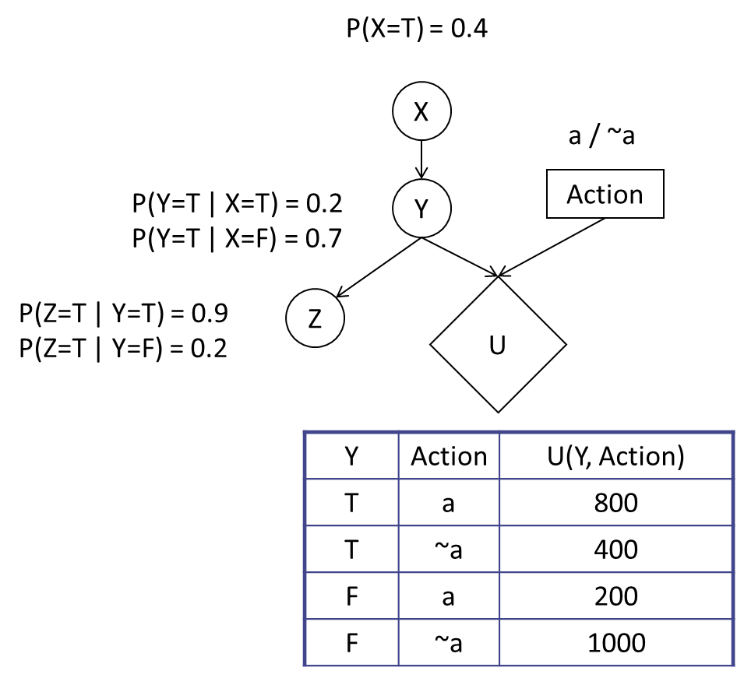

1. Which action should be taken? Justify your decision. **[7 pts]**

**Ans) It will take action ~a**

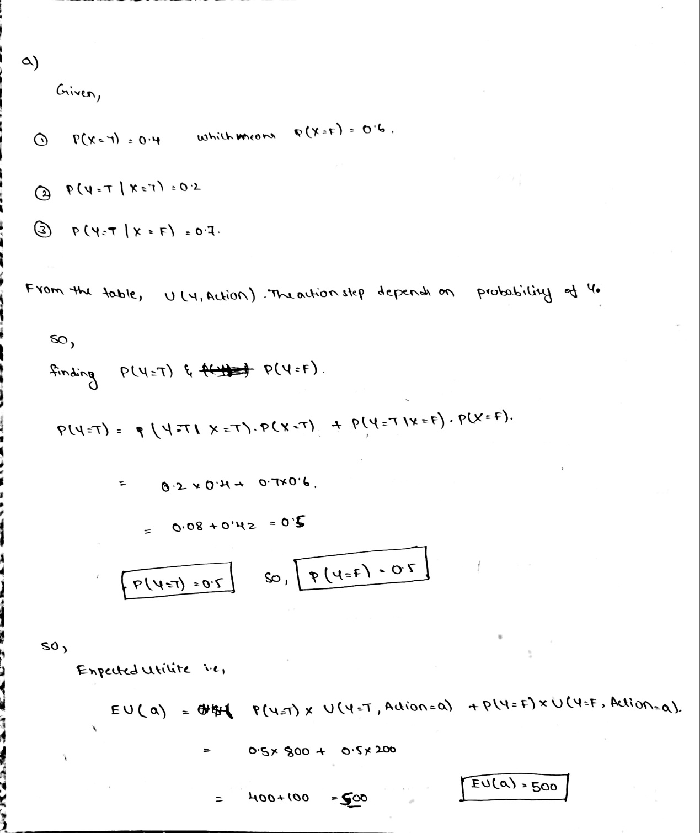

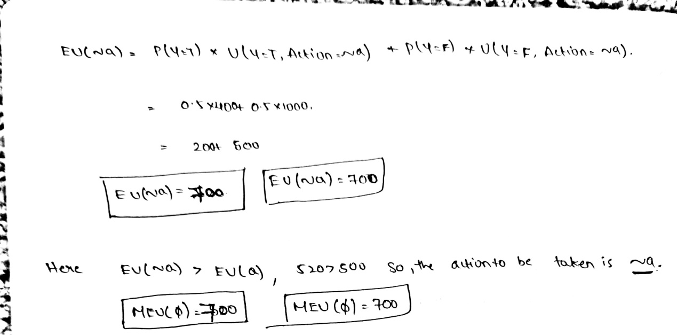

1. What is the value of information of Z? Justify your decision. **[8 pts]**

**Ans) VPI(Z)= 100**

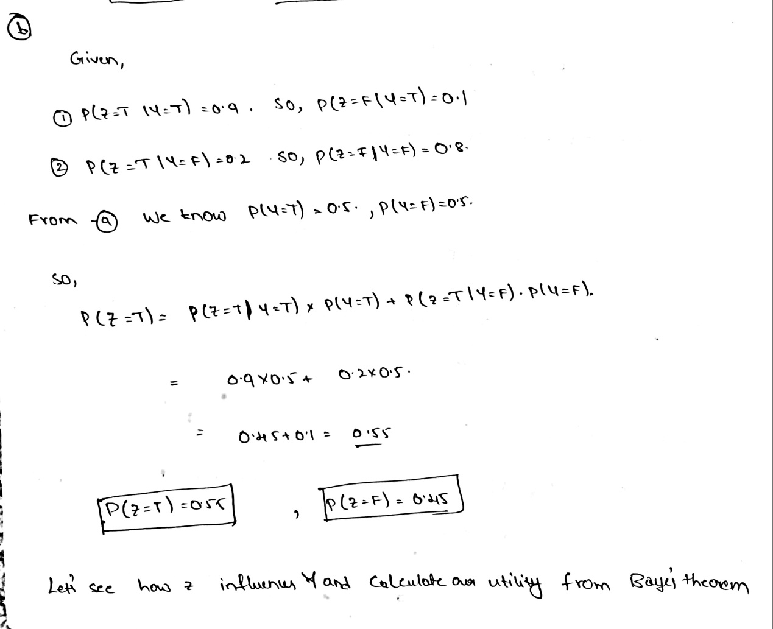

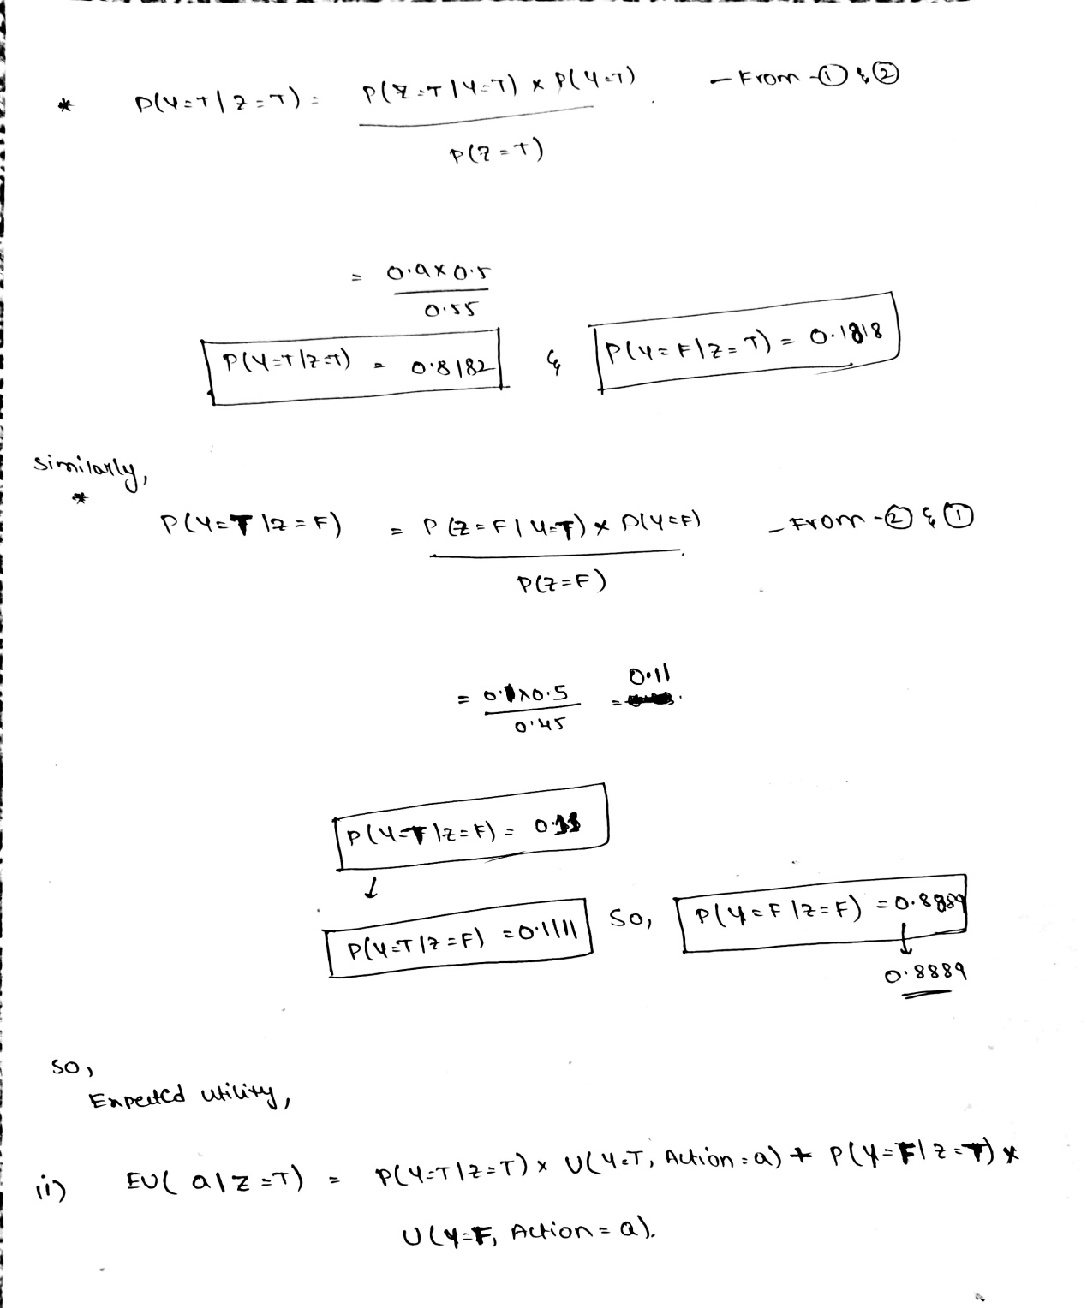

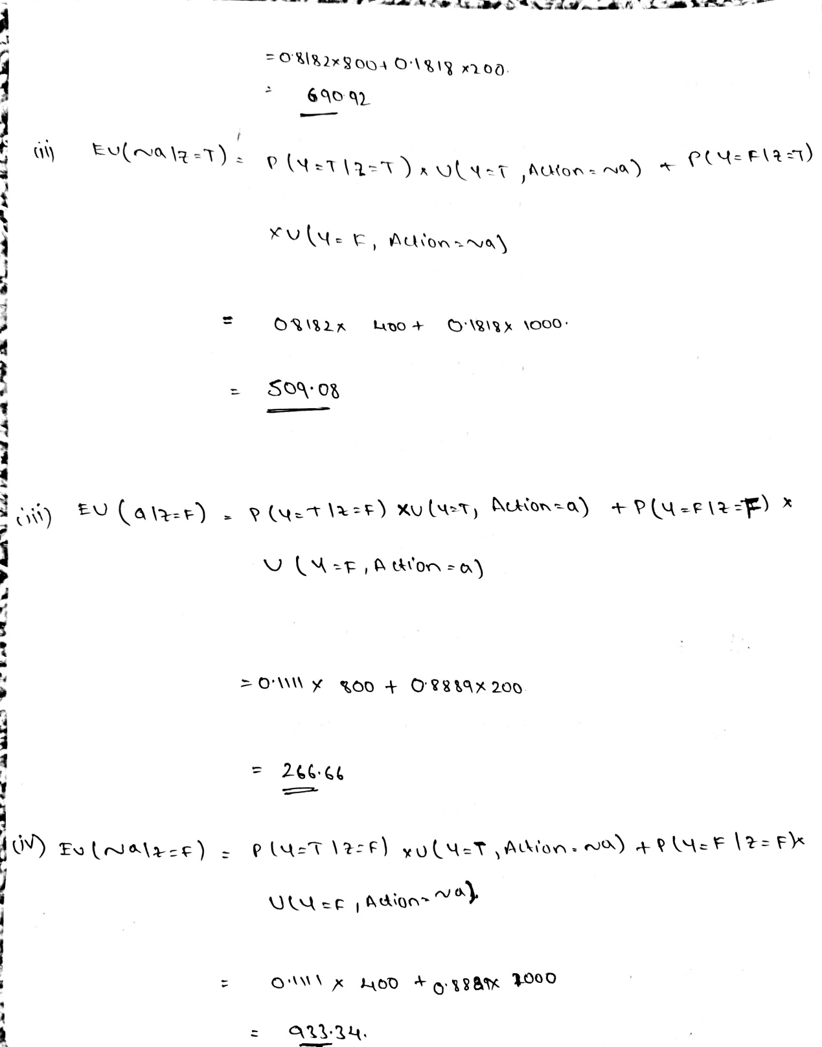

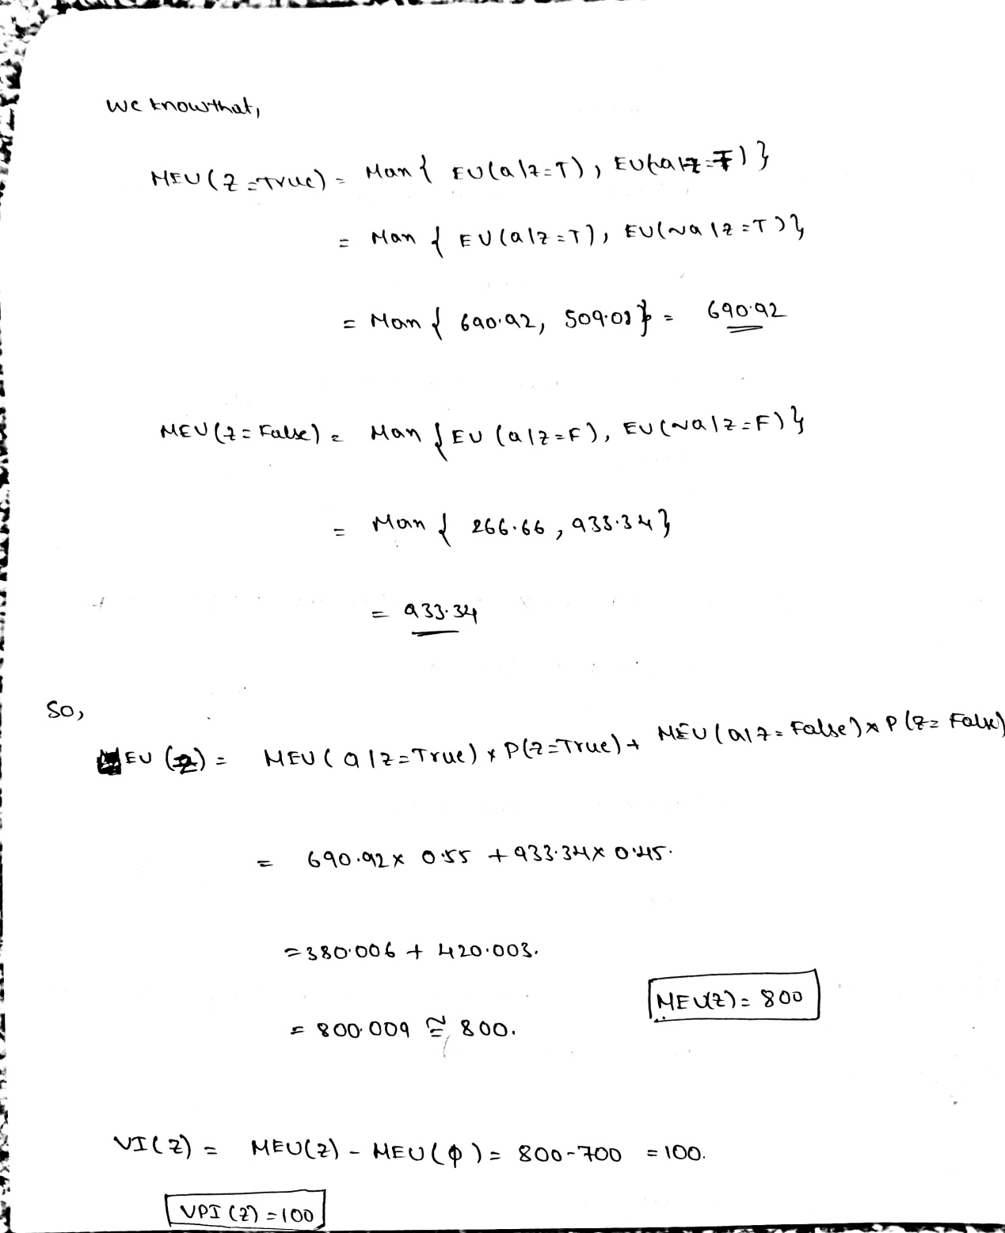

1. What is the value of information of X? Justify your decision. **[10 pts]**

Ans) VPI(X)=24

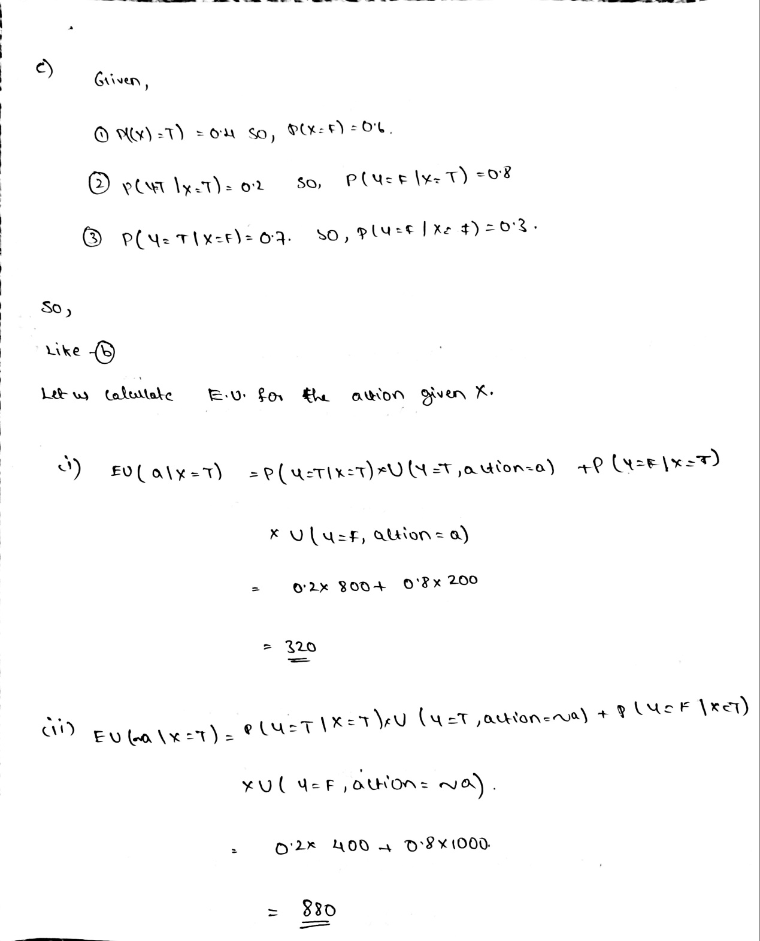

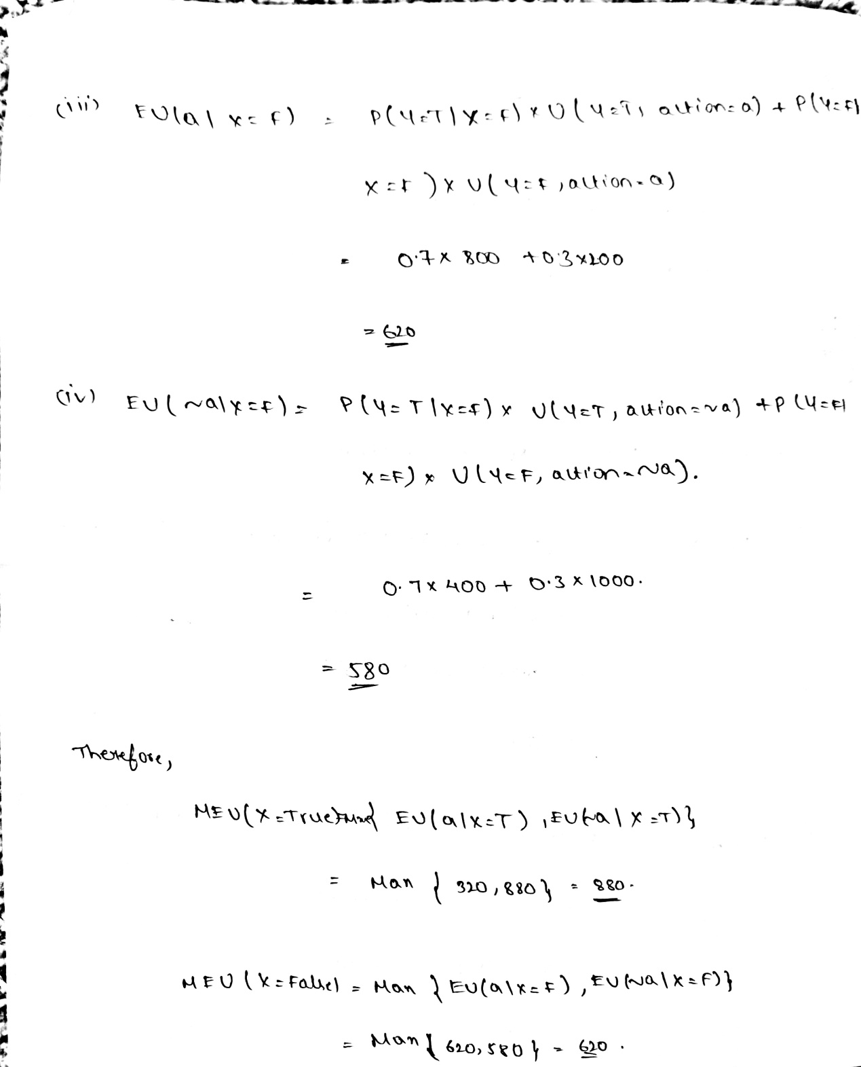

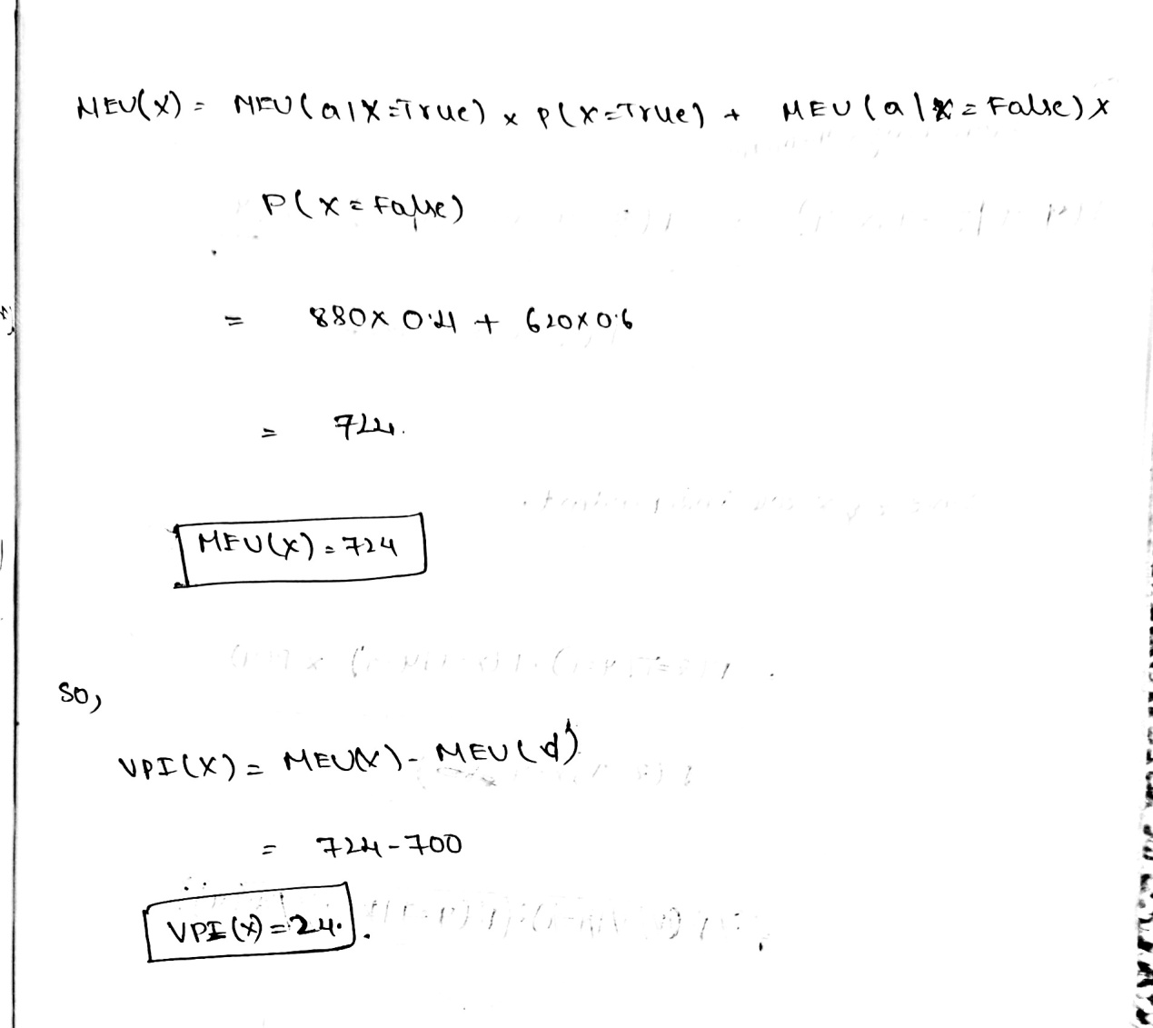

1. Given Z = T, what is the value of information of X? Justify your decision. **[10 pts]**

Ans) VPI(X|Z=T)= 30.72

